If you would like more practice before Quiz #2 here are some additional problems:

**Discovering Statistics – Daniel T. Larose (3rd edition)**

Chapter 6 - section 6.2 (page 339) #57 Binomial dist

Chapter 6 - section 6.4 (page 364) #33 & #35 Normal dist

Chapter 9 - (pg. 539) #25 Hypothesis test (1 sample)

Chapter 11 - section 11.2 (page 659) #29 Chi-square test for independence

You can find these problems by going to the **eBook** in LaunchPad and selecting the appropriate chapter, section and then page noted. The solutions are also given (below the problem) so you can check your answers.

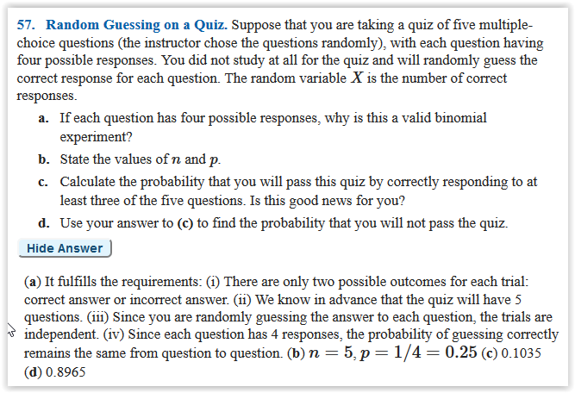

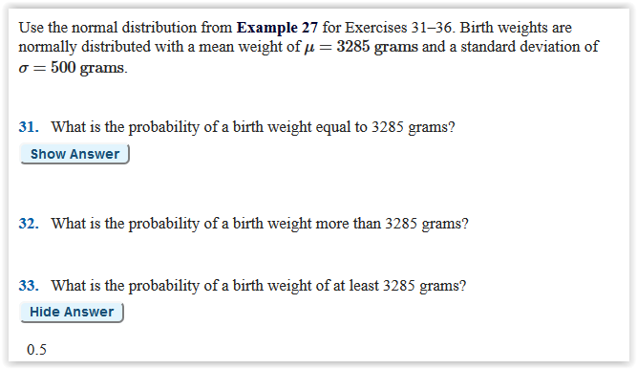

#33

$z=\frac{x-μ}{σ}$, µ = average of the sample of 3285, $σ$ =standard deviation=500, x = the point you are interested in finding the probability for, 3285 or more

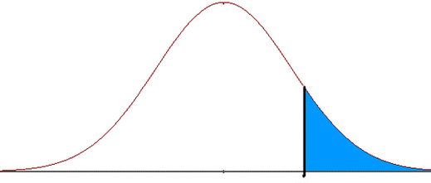 so we want 1 – the probability

Z =0, probability = .5, 1-.5 = .5

#35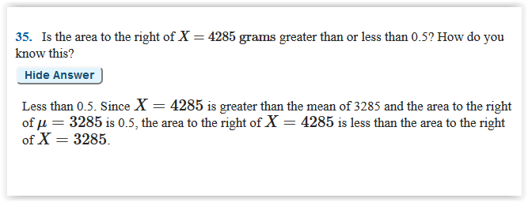

$z=\frac{x-μ}{σ}$, µ = average of the sample of 3285, $σ$ =standard deviation=500, x = the point you are interested in finding the probability for, 4285 or more

Z = 2, probability = .9772 is to the probability to the left of the point, we are interested in the probability to the right, so 1-.9772=.0228, which is less than .5

#25

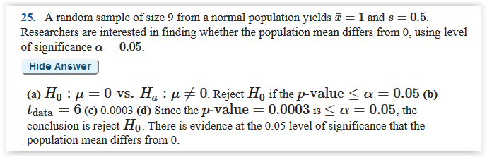

Purple chart, two tail test, small sample size

So T=(X bar – M)/(s/ sqrt of n)) = (1-0)/(.5/ sqrt of 9) = 1/(.5/3) = 1/.1666=6, look this up in t tables with df=n-1, 9-1=8, so pvalue = is off the table and is less than .01, therefore it is less than .05 and we can reject the null hypothesis and conclude there is a difference

#29

